**A PROJECT REPORT**

**As partial requirement for the degree of**

**Bachelor Of Computer Science**

**ON**

**Attendance Management System**

**SUBMITTED BY : University Exam No.**

1. **Patel Swetang B.**

**UNDER GUIDANCE OF**

**MR.NIRAV DESAI**

**COMPUTER SCIENCE DEPARTMENT,**

**Dolat-Usha Institute Of Applied Sciences And Dhiru-Sarla Institute of Management & Commerce, Valsad**

**Affiliated with**

**Veer Narmad South Gujarat University, Surat**

**\* 2019-2020 \***



Computer Department

CERTIFICATE

This is to certify that the project work is satisfactorily carried out on **Attendance Management System_** is a work done by Mrs. **_PATEL SWETANG B.**  in partial fulfillment of the requirement for the award of the degree of **B.Sc.(Computer Science)**  during the academic year 2019-20.

__________________ ___________________

Dr. Snehal Joshi Dr. Pankaj Desai

Head of Department Principal

Mr.Nirav Desai

Project Internal Guide

Project Certified Date: _____________

At T.Y B.Sc. Examination

Examiners:

1. ________________

2. _______________

**DOLAT-USHA INSTITUTE OF APPLIED SCIENCES AND**

**DHIRU-SARLA INSTITUTE OF MANAGEMENT & COMMERCE, VALSAD**

**Project Assessment Detail (internal)**

Project Group Code: - 09

Project Title: -ONLINE CAR PARKING BOOKING

Internal Guide: - MR.NIRAV DESAI

Group Members Name: - 1. Patel Swetang B.

|  |  |  |  |  |  |  |
| --- | --- | --- | --- | --- | --- | --- |
| Week No. | Week From – Week To | Date of Report | Topic | Task Schedule for Next Week | Remarks of Internal Guide | Signature of Internal Guide |
| 1 |  |  |  |  |  |  |
| 2 |  |  |  |  |  |  |
| 3 |  |  |  |  |  |  |
| 4 |  |  |  |  |  |  |
| 5 |  |  |  |  |  |  |
| 6 |  |  |  |  |  |  |
| 7 |  |  |  |  |  |  |
| 8 |  |  |  |  |  |  |

**INDEX**

|  |  |  |
| --- | --- | --- |
| **Sr. No.** | **Topics** | **Page No** |
| **[1]** | **PROJECT PROFILE** | **5** |
|  |  |  |
|  | **1.1 Project Goal** | **6** |
|  | * 1. **Project Scope** | **7** |
| **[2]** | **SYSTEM ENVIRONMENT** | **8** |
|  |  |  |
| **[3]** | **PLATFORM ENVIROMENT** | **9** |
|  | **3.1 FRONT END PHP** | **9** |
|  | **3.2 BECKEND MYSQL** | **11** |
|  |  |  |
| **[4]** | **SYSTEM ENV. ANALYSIS MODULE** | **12** |
| **[5]** | **Data Flow Diagram(DFD)** | **13** |
|  | **(A) Zero level Diagram** | **13** |
|  | **(B) First level Diagram** | **14** |
|  |  |  |
| **[6]** | **SYSTEM DESIGN** | **15** |
|  | **6.1 E-R Diagram** | **15** |
|  | **6.2 Data Dictionary** | **16** |
| **[7]** | **SCREEN SHORT** | **19** |
|  | **7.1 Screen Shorts of Forms and Code** |  |
|  |  |  |
|  |  |  |
| **[9]** | **CONCLUSION & FUTURE ENHACEMENT** |  |
| **[10]** | **REFERENCES** |  |

**1.PROJECT PROFILE**

**INTRODUCTION**

* The system entitled “Attendance Management System” is a website that takes Attendance of Students.
* This project is designed to be used for take attendance of students very easily.
* *Attendance Management System* is a website that helps Faculties to take Attendance without physically write on paper.
* Admin Access the Site and Add, Update and Delete the Faculties and Students. The Site has an Administrator who keeps an Eye on the overall functioning of the System.

**1.1 PROJECT GOALS AND OBJECTIVE**

**PROJECT GOALS**

* This project is designed to be used for take attendance of students very easily.
* **Attendance Sanagement System** is a website that helps Faculties to take paperless Attendance.

**OBJECTIVES**

1. **ADMIN:-**

* To login into site.
* To manage the Faculties(Add/Update/Delete).
* To manage the Students (Add/Update/Delete).
* Admin will get all reports of students and faculties.

1. **FACULTY:-**

* To login into site.
* Take Attendance of Students.
* Faculty will get reports.

1. **STUDENT:-**

* To login into site..
* Students will get reports.

**1.2 SCOPE OF THE PROJECT**

PHP technology used for the development of the application.

This software acts as an office that is open 24/7.

It increases the efficiency of the attendance management at collage.

**2.SYSTEM ENVIRONMENT**

**HARDWARE REQUIREMENTS:-**

* Processor:- Intel core i3
* Hard disk:-8gb
* Ram:- 4gb

**SOFTWARE REQUIREMENTS:-**

* Windows7
* Wamp server 2.0

**3.PLATFORM ENVIRONMENT**

**3.1 Frontend:-PHP (version 2.0.0)**

**PHP**

**What is php and what is it used for**

PHP is a general-purpose scripting language that is especially suited to server-side web development, in which case PHP generally runs on a web server. Any PHP code in a requested file is executed by the php runtime, usually to create dynamic web page content or dynamic images used on websites or elsewhere.

**What is php developers do**

PHP developers develop programs, applications, and web sites using the dynamic scripting language PHP. PHP is known for web development and business applications. Depending on job functions, PHP developers may be classified as software developers may be classified as software developers or web developers.

**What language is php written in**

That separate program, the PHP interpreter, is itself written in C. C# is a compiled language, but it is not compiled to machine code. Instead, it is complicated to a specialist language, byte code, to be run on a virtual machine. Java is another example of such a setup.

**Why php is called hypertext preprocessor and open source**

“PHP/FI” was also another name for PHP. PHP is called hypertext preprocessor as its libraries are already compiled. When any person request for any php page in the address bar of the browser that request is first sent to the server then server interpret php files and return back responses in form of Html.

**ADVANTAGES OF PHP:-**

**Open source**:- It is developrd and maintained by a large group of php developers, this will helps in creating a support community, abundant extension library.

**Speed:-** It is relative fast, since it used much system resources.

**Easy to use:-**It uses C like syntax, so for those who are familiar with c, it’s very easy for them to pick up and it is very easy to create website scripts.

**Stable:-** Since it is maintained by many developers, so when bugs are found it can be quickly fixed.

**Powerful library support:-** You can easily fine functional modules you need such as pdf, graph etc.

**3.2 Backend:-MYSQL(version 2.0.0)**

**MYSQL**

MYSQL is a database system used by many websites on the internet. It is based on sql. There are many ways of doing things in sql are similar in mysql.

MYSQL is the words most popular opensource database with its proven performance,reliability and ease of use, mysql has become the leading database choice for web based application, used by high profile web properties including facebook, twitter, youtube, yahoo and many more.

**ADVANTAGES OF MYSQL:-**

MYSQL is an open source database system. Hence it can be downloaded and used by the developer for free.

MYSQL is robust and it provides excellent performance due to usage of MYISAM.

MYSQL occupies very less disk space.

MYSQL can be easily installed in all major operating systems like Microsoft Windows, Linux and UNIX.

MYSQL can be easily learnt using the tutorials that are available on internet.

MYSQL is best suited for small and medium application.

**4.SYSTEM REQUIREMENT ANALYSIS**

**MODULES**

* **ADMIN**
* **FACULTY**
* **STUDENT**

1. **ADMIN MODULE:-**

**Login**

* To do login
* Bookings can be done

**Insert , Update and Delete**

* Insert Faculties and Students Data
* Update Faculties and Update Students
* Delete Students And Faculties

**Report**

* Admin will get reports

1. **FACULTY MODULE:-**

**Login**

* Faculty can login

**Attendance**

* Faculty can take Attendance

**Report**

* Faculty will get reports of Students

1. **STUDENT MODULE:-**

**Login**

* Student can login

**Report**

* Student will get reports of their own attendance

**5.SYSTEM DESIGN**

**DFD (Data flow diagram)**

**5.2 ZERO OR CONTEXT LEVEL DFD**



**FIRST LEVEL DFD**



**SECOND LEVEL DFD**







**5.3 ER DIAGRAM**



**6. DATA DICTIONARY**

**1).Admin**

|  |  |  |  |  |
| --- | --- | --- | --- | --- |
| **Column** | **Type** | **Size** | **Default** | **Comments** |
| admin_id | varchar | 10 | Primery key |  |
| password | varchar | 30 |  |  |

**2).Staff_master**

|  |  |  |  |  |
| --- | --- | --- | --- | --- |
| **Column** | **Type** | **Size** | **Default** | **Comments** |
| name | Varchar | 20 |  |  |
| phone | Int | 10 |  |  |
| semister | Varchar | 20 |  |  |
| branch | Varchar | 20 |  |  |
| class | Varchar | 20 |  |  |
| subject | Varchar | 30 |  |  |
| email | Varchar | 35 | Primery key |  |
| password | Varchar | 35 |  |  |

**3).Student_master**

|  |  |  |  |  |
| --- | --- | --- | --- | --- |
| **Column** | **Type** | **Null** | **Default** | **Comments** |
| name | varchar(30) | 30 |  |  |
| gender | Varchar | 10 |  |  |
| rollno | Int | 10 | Primary key |  |
| semail | Varchar | 35 |  |  |
| branch | Varchar | 30 |  |  |
| class | varchar | 30 |  |  |
| idname | varchar | 15 |  |  |
| password | varchar | 35 |  |  |
| date | date | 10 |  |  |

**4). Timetable**

|  |  |  |  |  |
| --- | --- | --- | --- | --- |
| **Column** | **Type** | **Size** | **Default** | **Comments** |
| faculty name | varchar | 30 |  |  |
| tid | int | 10 | Primary key |  |
| email | varchar | 30 |  |  |
| semister | varchar | 20 |  |  |
| branch | varchar | 20 |  |  |
| class | varchar | 20 |  |  |
| subject | varchar | 20 |  |  |
| day | varchar | 20 |  |  |
| date | date | 10 |  |  |
| time | time | 6 |  |  |

**5). Attendance_master**

|  |  |  |  |  |
| --- | --- | --- | --- | --- |
| **Column** | **Type** | **Null** | **Default** | **Comments** |
| Aid | int | 10 |  |  |
| email | varchar | 30 |  |  |
| facultyname | varchar | 30 |  |  |
| name | int | 10 |  |  |
| rollno | Int | 10 |  |  |
| date | Int | 10 |  |  |
| class | Int | 10 |  |  |
| A/P | int | 10 |  |  |

**Admin:**

Index.php

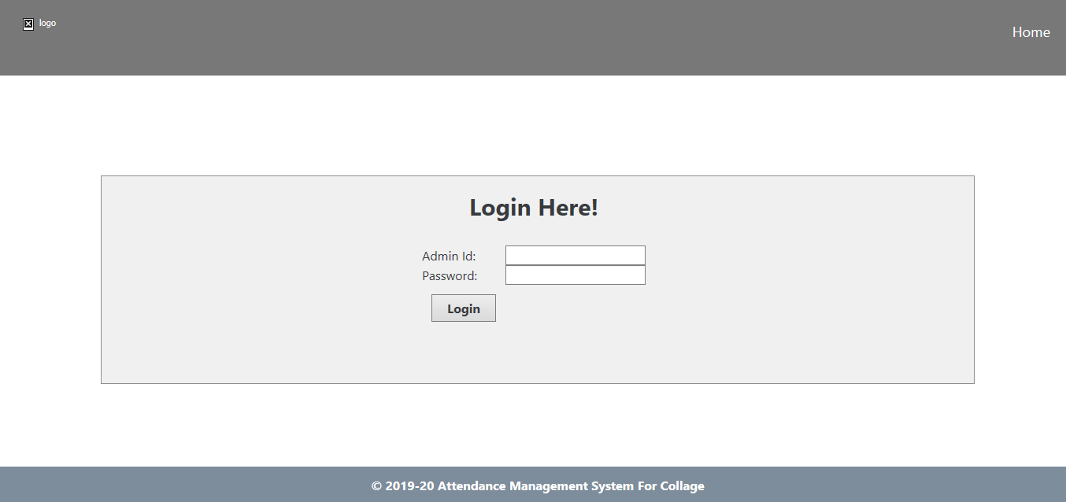

Addstaff.php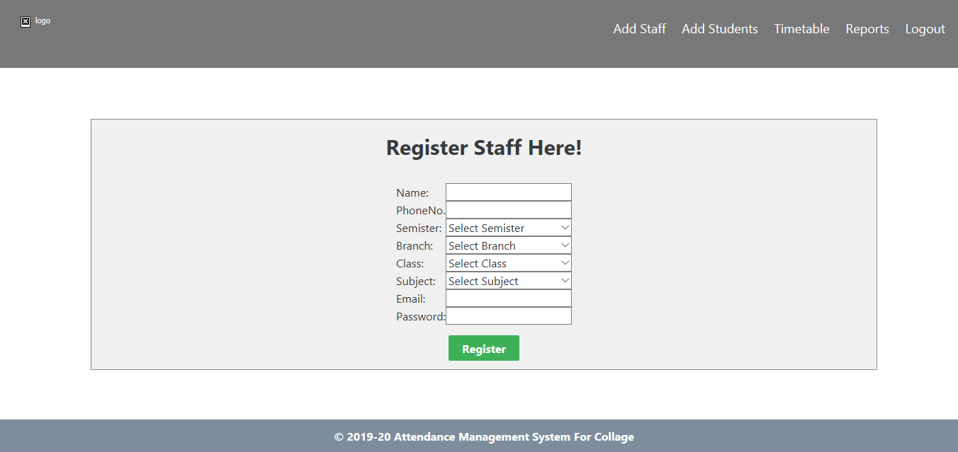

Addstudent.php

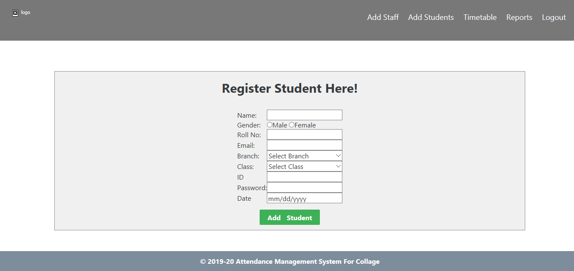

Timetable.php

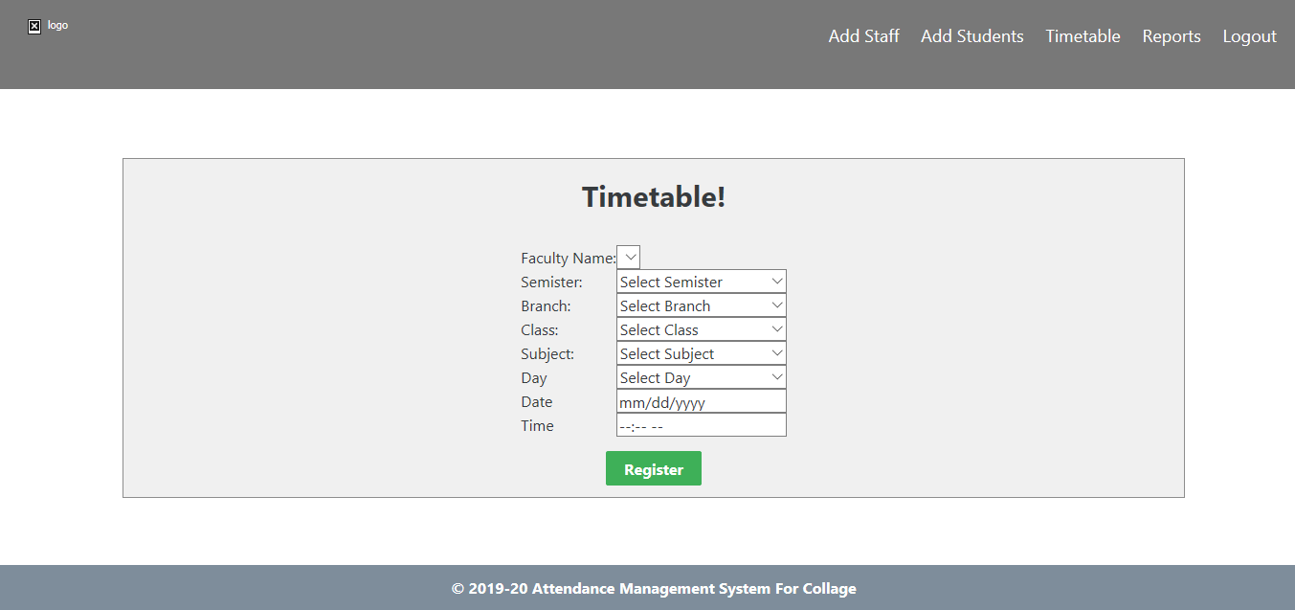

Reports.php

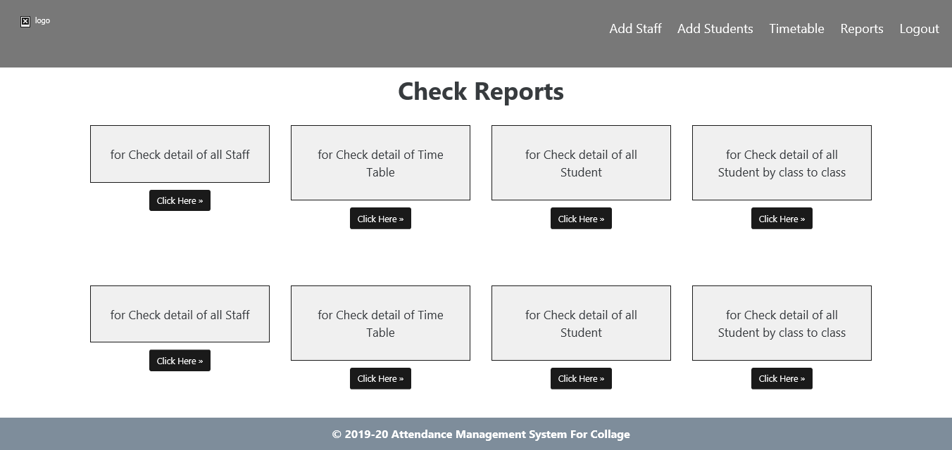

**Faculty:**

Index.php

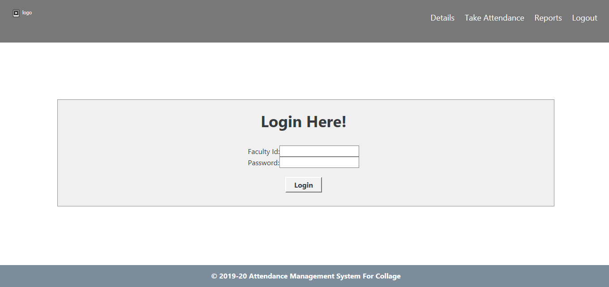

Reports.php

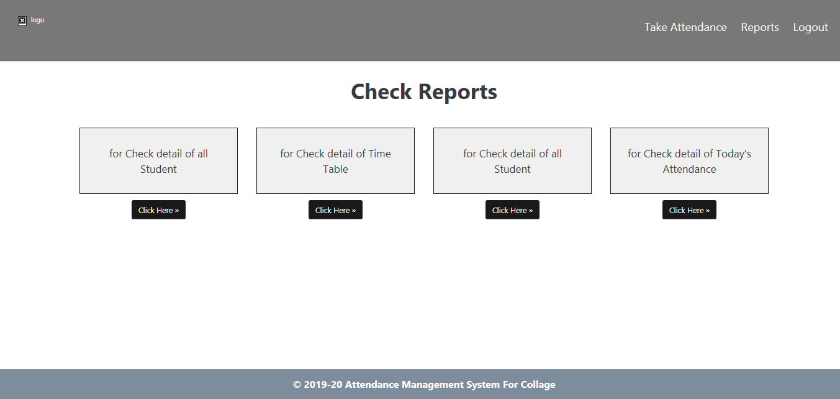

**Student:**

Login.php

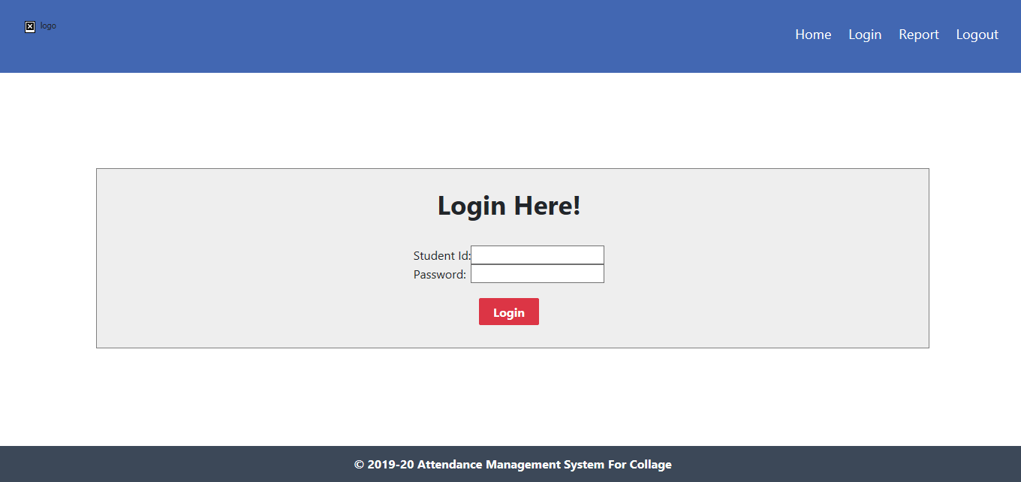

Reports.php

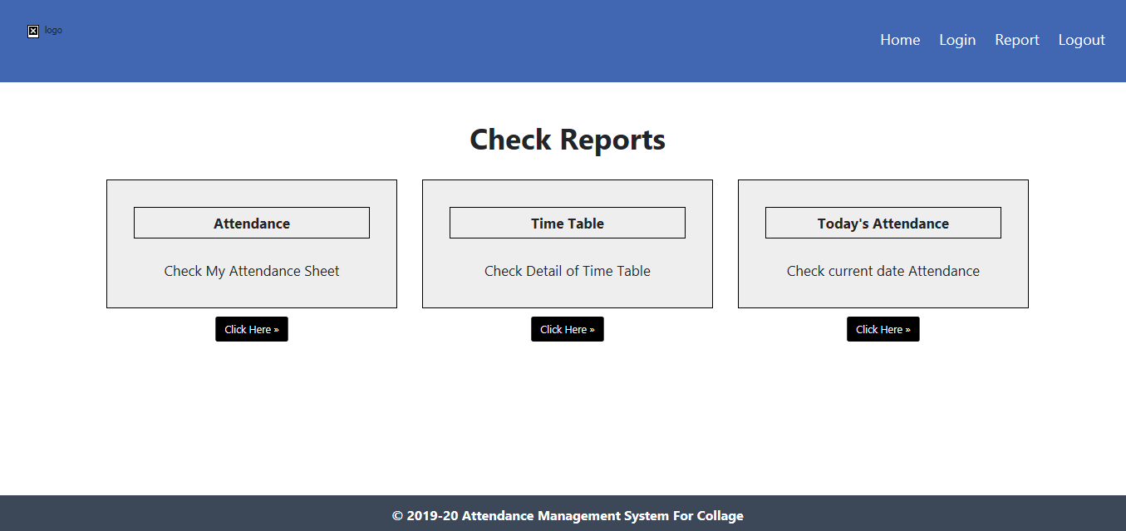

**10. CONCLUSION AND FUTURE ENHANCEMENT**

**CONCLUSION:-**

This software helps the Faculties to take Attendance without having confusion. Faculty can easily change students attendance if any mistake happen.

**FUTURE ENHANCEMENT:-**

In future, our application will overcome the flaws if occurred, and attains new features offered to customers for flexible and easy transportation.

Following are the enhancements to the application:-

* Providing good user interface
* Trying to implement fingerprint

**11. REFERENCES**

* PHP BLACK BOOK
* ESSENCE OF PHP
* PHP WITH MYSQL
* WWW.GOOGLE.COM